**Common dinner**

Wednesday 8 October 2025, 19:00, Gasthaus Wild, Radetzkyplatz 1, 1030 Wien

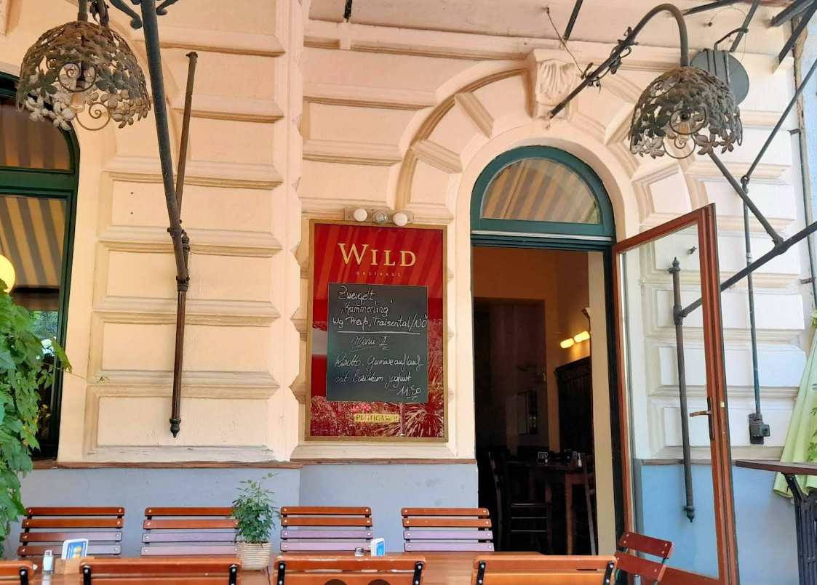

From the ministry: when exiting turn right into Radetzkystraße and walk to Radetzkyplatz. The restaurant is on the right side.

From Ruby Sofie Hotel: exit and turn right, turn right into the second road (Kollergasse), turn left into the third road (Lorbeergasse) and pass under the railway, then turn right on Obere Viaduktgasse and walk to Radetzkyplatz, where the restaurant is on your left side (10 min walk)

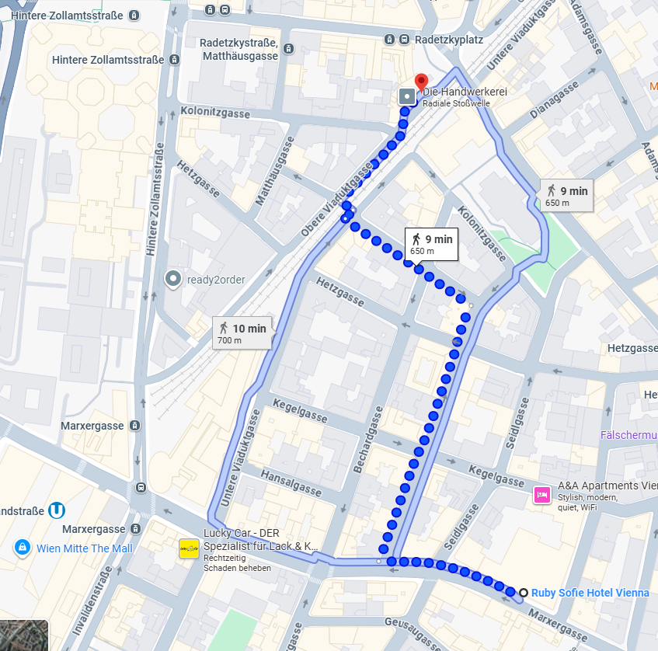

Ministry